# Business question 1

select distinct(p.product_name), f.product_code, f.base_price, f.promo_type

from dim_products as p

inner join fact_events as f

on p.product_code = f.product_code

where base_price > 500 && promo_type= 'BOGOF'

order by product_name;

# 

# Business question 2

select distinct(city), count(store_id)

from dim_stores

group by city

order by count(store_id) desc;

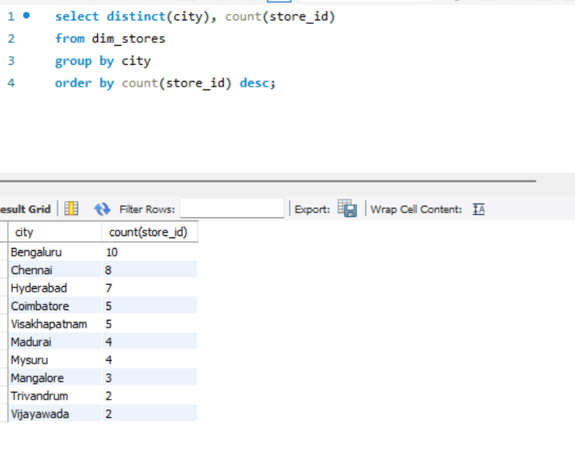

# Business question 3

select campaign_name,

concat(format(sum(base_price*quantity_sold_before_promo)/1000000,2), 'M') AS total_revenue_before_promo,

concat(format(SUM(quantity_sold_before_promo * base_price) / 1000000, 2), 'M') AS total_revenue_after_promo

from dim_campaigns as c

inner join fact_events as f

on c.campaign_id = f.campaign_id

group by campaign_name

order by campaign_name asc;

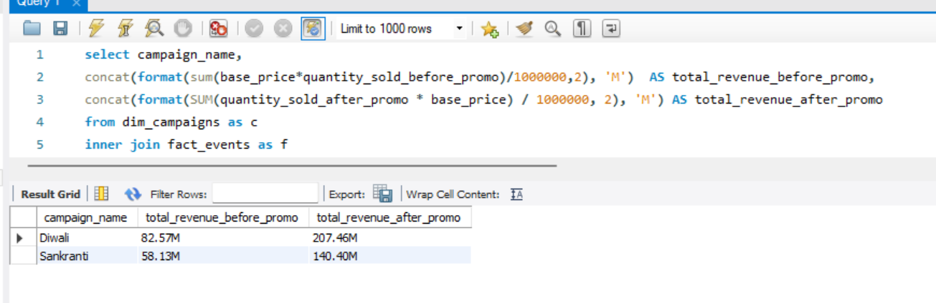

# Business question 4

select category,

round((((sum(quantity_sold_after_promo) - sum(quantity_sold_before_promo))/sum(quantity_sold_before_promo))*100), 2) AS ISU_Percent,

rank() over (order by((((sum(quantity_sold_after_promo) - sum(quantity_sold_before_promo))/sum(quantity_sold_before_promo))*100)) desc)

as Rank_order

from dim_products as p

inner join fact_events as f

on p.product_code=f.product_code

group by category

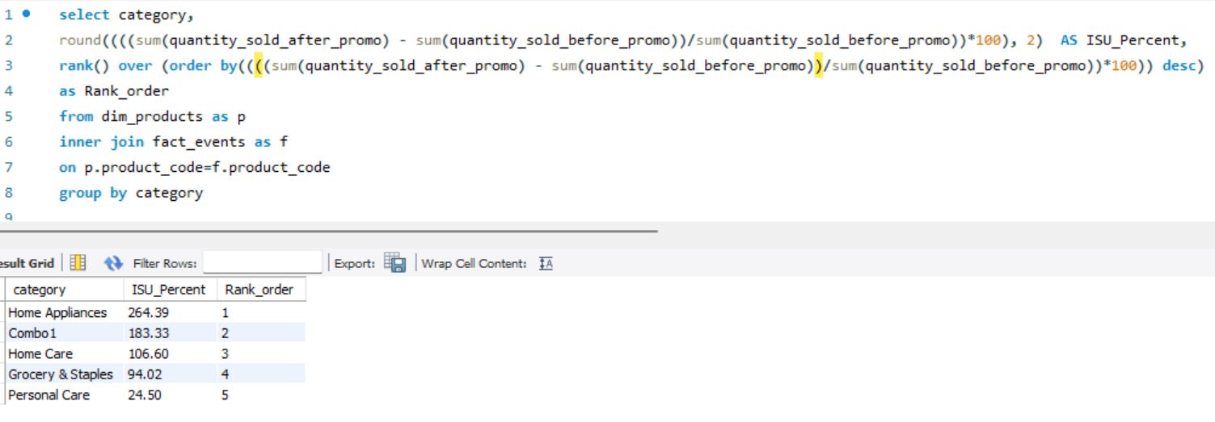

# Business question 5

Select product_name, category,

Round((((SUM(quantity_sold_after_promo * base_price) - SUM(quantity_sold_before_promo * base_price))

/ SUM(quantity_sold_before_promo * base_price))*100), 2) As IR_PERCENTAGE

from dim_products as p

Inner Join fact_events as f

on p.product_code = f.product_code

Group By p.product_name, p.category

Order By IR_PERCENTAGE desc

Limit 5;

